Engineering vs Nature

The Importance of Rivers
Rivers are a creation of nature that not only form ecosystems with rich biodiversity but also represent a source of beauty and admiration. They are shaped over time and are very difficult to recreate once destroyed.

Causes of River Filling
The filling of rivers mainly occurs due to human intervention and the need for urban development. Rivers are often seen as obstacles to construction projects such as roads and buildings, leading to their burial in order to save space and cost. Additionally, due to lack of awareness, many people mistakenly believe that filling rivers helps prevent floods, while in reality it disrupts the natural flow of water. The absence of proper architectural planning, combined with economic interests, drives people to engage in unethical and reckless destruction of the natural environment.

Consequences of River Filling
River filling has serious consequences for both biodiversity and the sustainability of an area, as it rapidly alters the natural ecosystem. It destroys riverbeds and riparian zones, which serve as shelters and breeding grounds for many species of plants and animals. The disappearance of rivers leads to population declines and even extinction of species that depend directly on river ecosystems.
Furthermore, the loss of species disrupts food webs: decomposers increase while consumers decrease. This environmental degradation affects not only nature but also humans, as it reduces the sustainability of the area—the ability to support activities such as agriculture, fishing, and recreation.
In addition, it increases the risk of flooding in residential areas, causes soil erosion, and contributes to the overall environmental degradation, making the area less sustainable both ecologically and socially.
Covering natural riverbeds reduces the river’s capacity, causing water to overflow more quickly during heavy rainfall. Also, building on natural riverbeds blocks water pathways, preventing proper drainage to the sea and leading to flooding in residential areas.

Impact on Our Area
Flooding caused by river filling has significantly affected our area, Polis Chrysochous, both environmentally and socially. This past winter, three major floods occurred, causing ongoing negative impacts.
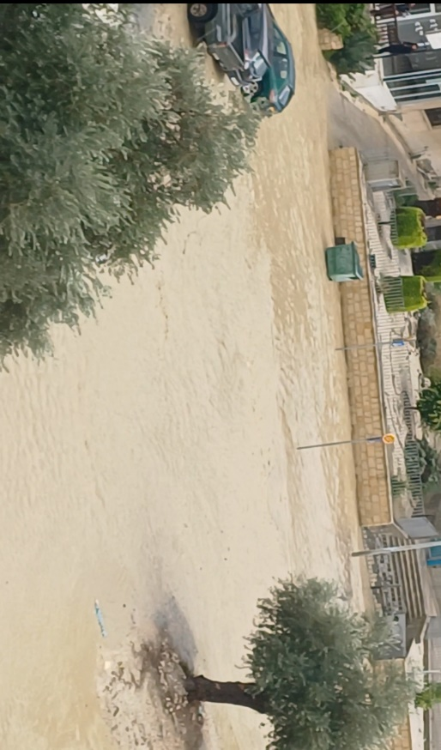
The strong water flow has destroyed natural habitats as well as local flora and fauna, reducing biodiversity. For example, our area used to be home to many freshwater turtles that lived in rivers. Today, those rivers have been replaced by the basements of houses and businesses built over them. As a result, these turtles have disappeared.
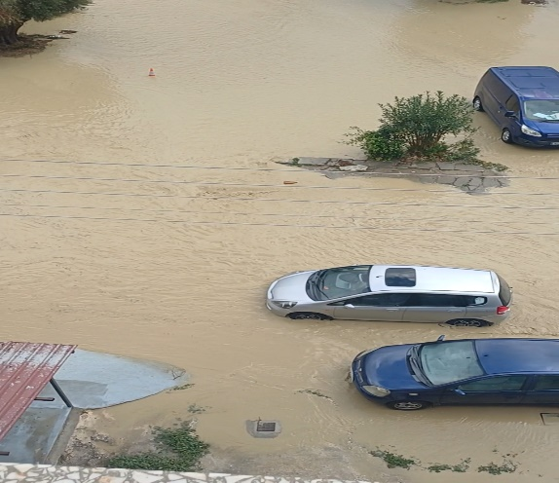
At the same time, homes and infrastructure such as supermarkets, shops, and businesses have been severely affected, reducing the overall sustainability of the area.

Survey Results
Adults
- Which animal do you believe lived in Polis Chrysochous 40 years ago?
69% Turtle
23% Bird
8% None
0% Crocodile
- Do you consider our area sustainable?
70% Slightly
15% Not at all
15% Quite
0% Very
- Who do you consider responsible for flooding in our area?
69% All
15% Government
16% Municipality
0% Residents
- In 15 years, the population will:
23% Increase
54% Decrease
23% Remain stable
Students
- What do you think existed where our school stands 50 years ago?
64% River
18% Another building
9% Agricultural land
9% Empty space
- Which animal lived in this area 50 years ago?
27% None
55% Bird
18% Turtle
0% Crocodile
- Who is responsible for environmental destruction?
64% Everyone
36% Humans
0% Government
0% Municipality
- Do you believe humans are responsible for the destruction of the river?
9% No
55% Yes
36% Partially

Conclusion
From the results above, we conclude that older people were aware of the biodiversity that once existed in our area, while younger people are not. This highlights the environmental degradation that has taken place over recent years.

Interview with a Local Resident
Q: What do you think causes flooding in Polis Chrysochous?
A: Poor flood-control projects, urban planning issues, and bad construction practices that led to river filling.
Q: How do you remember the area during your school years?
A: It was sparsely populated. There was a river with turtles near the school, and there were fewer buildings and fences. It was very different.
Q: Who do you consider responsible for this issue?
A: The government and municipality, for granting building permits without proper studies, and the misuse of rivers as dumping sites.
Q: Do you think biodiversity has decreased in the area?
A: Yes, it has. About 15 years ago, there were turtles in the river, but now they have disappeared. The excessive use of strong insecticides also destroyed plant and animal life in the rivers.

Solutions
Flooding can be addressed through a combination of technical and urban planning solutions. One effective approach is the creation of controlled or engineered river channels that collect excess water and direct it to storage areas such as reservoirs or artificial lakes. This water could then be used for energy production or irrigation.
In coastal areas, water could also be directed to desalination units, contributing to the production of drinking water.
At the same time, it is essential to conduct proper architectural and urban planning studies that take into account the natural flow of water, preventing future damage. Improving or replacing inadequate infrastructure is also crucial, so that cities can better manage heavy rainfall and reduce flood risks.
Names: Anna Evangelou (Katerina Chrysostomou) Panagiotou Freideriki, Psaropoulou Ivi and Kypri Antria
Βibliography:
www.kee.gr/perivallontiki/teacher4_3.html
https://etek.org.cy/uploads/news/85c0aa784c.pdf
https://www.philenews.com/kipros/topika/article/1654939/provlimata-apo-tin-kakokeria-stin-poli-chrisochous-sinechizonte-i-ergasies-apokatastasis/
https://moa.gov.cy//moa/wdd/wdd.nfs/page13_gr/page13_gr?opendocument

